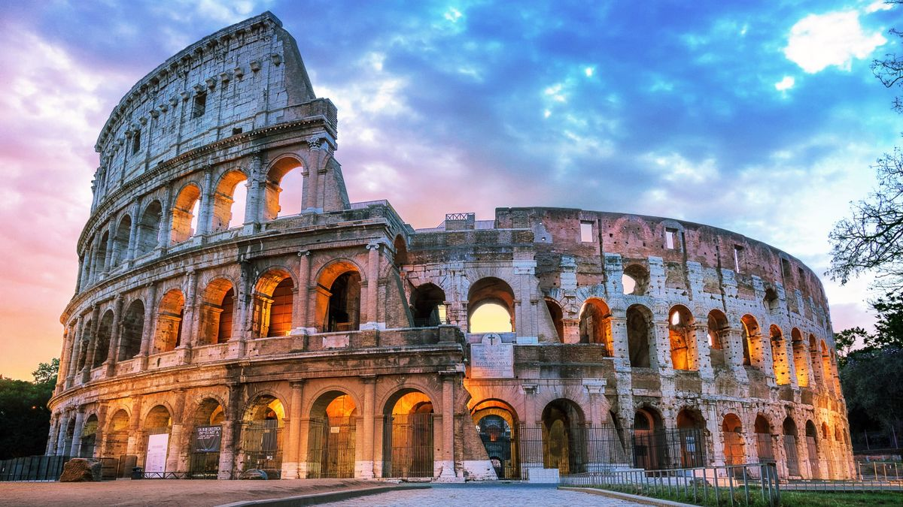**Roman Colosseum**

The Roman Colosseum, an iconic amphitheater in the heart of Rome, is a symbol of ancient Roman engineering and entertainment. Built in the 1st century CE, it hosted gladiator contests and public spectacles, accommodating tens of thousands of spectators, showcasing the grandeur of Roman architecture and culture.

**History**

The Roman Colosseum, officially known as the Flavian Amphitheatre, was commissioned by Emperor Vespasian of the Flavian dynasty in AD 72 and completed in AD 80 by his successor Titus. This monumental arena, capable of holding 50,000 to 80,000 spectators, was used for gladiatorial contests, animal hunts, mock sea battles, and public executions.